CLOUD FORESNSIC INVESTIGATION

PREPARED BY: ELIZABETH NWOFOR

ROLE: LEAD CLOUD FORENSIC ENGINEER

EXECUTIVE SUMMARY
A forensic investigation was conducted on AWS CloudTrail logs following a suspected cloud compromise. The analysis revealed that an attacker successfully compromised an IAM access key, escalated privileges, accessed sensitive data, and established persistence within the environment.

The attacker demonstrated advanced techniques including:
- Credential abuse
- Privilege escalation
- Data exfiltration
- Backdoor creation
- Log evasion tactics

The attack originated from an external IP and later transitioned to a secondary IP for persistence and stealth operations.

METHODOLOGY
The investigation followed a structured forensic approach:
- Log Analysis
CloudTrail logs were parsed and analyzed chronologically to reconstruct attacker activity.

- Event Correlation
Events were grouped based on:
- Access Key ID usage
- Source IP addresses
- API call patterns

- Threat Hunting
Suspicious behaviors were identified based on:
Unusual API calls (e.g., PutUserPolicy, CreateUser)
Access from external/public IPs
Access to sensitive services (S3, Secrets Manager, IAM)

- Data Decoding
Base64-encoded strings were decoded to reveal hidden or obfuscated information.

- Behavioral Analysis
Normal system activity was separated from malicious activity using:
- Known AWS internal IP ranges
- Expected service behavior
- User activity baselines

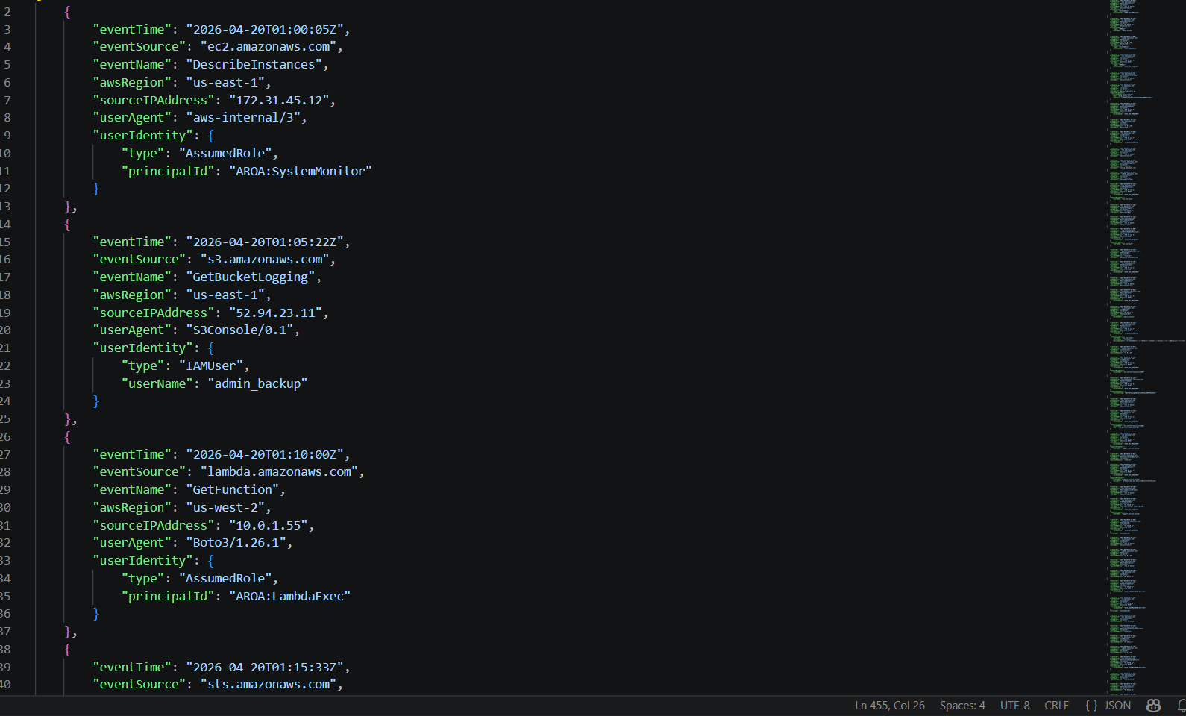
Json view of cloudtrail log

REQUIRED DELIVERABLES
- Credentials Discovery
The access key AKIA_DEV_PROD_9982 is the primary credential used by the attacker for the bulk of the attack. It first appears at 01:15:33Z when an external IP (190.45.112.3) uses it to call GetCallerIdentity — an attacker's standard first step to verify that a stolen key is valid and determine what account it belongs to.

This key was then used continuously from 190.45.112.3 to conduct reconnaissance, privilege escalation, data exfiltration, and backdoor creation. It was eventually deactivated by the attacker themselves at 04:50:33Z using the backdoor key, to cover their tracks and prevent defenders from using the same key to investigate.

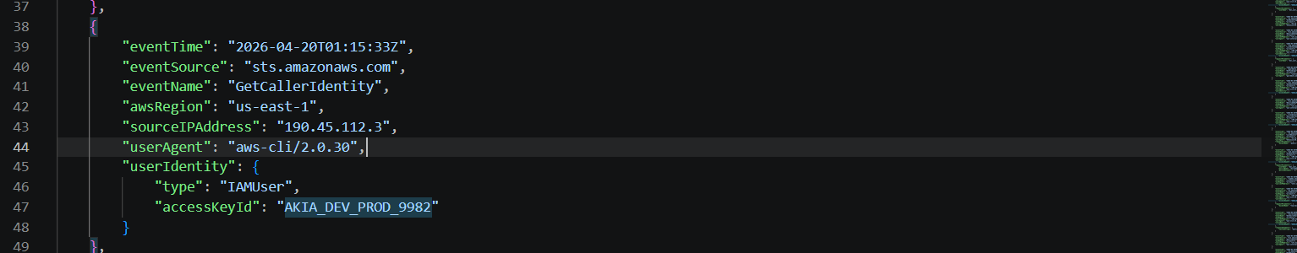

- IP Forensic Tracking
Initial Attacker IP:
IP 190.45.112.3 is the initial attack IP. It first appears at 01:15:33Z using access key AKIA_DEV_PROD_9982 to call GetCallerIdentity — the attacker's way of verifying the stolen key works and identifying what AWS account they have access to. This IP is clearly external and not attributable to any known internal service.

Second Attacker IP
IP 45.33.10.11 first appears at 03:35:45Z performing CreateAccessKey for the backdoor user support_service_backup. This IP represents a second operational base the attacker. The attacker used this IP to aviod detection

— specifically for persistence and escalation operations. The use of a second IP is a deliberate operational security (OPSEC) measure to separate the initial compromise activity from the persistence phase, making correlation harder.

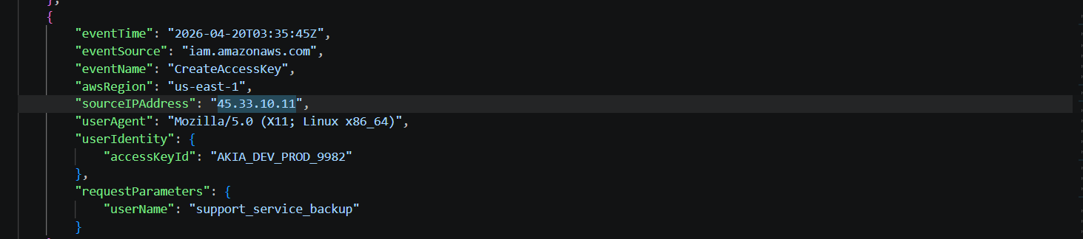

- Obfuscated Data Analysis
Two Base64 encoded strings were identified in the CloudTrail logs. Both were deliberately embedded to either hide malicious data or store legitimate configuration. The investigation decoded both using CyberChef.

String 1: Legitimate
Encoded: c2V0dGluZzogYmFja3VwX2VuYWJsZWQ9dHJ1ZQ==
Decoded: setting: backup_enabled=true
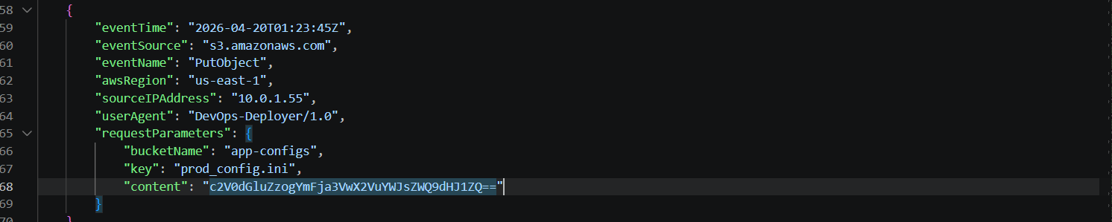

This is a routine DevOps configuration deployment. The source IP 10.0.1.55 is an internal address using the DevOps-Deployer tool. The decoded value 'setting: backup_enabled=true' is a harmless configuration flag. The Base64 encoding here is standard practice for embedding configuration content in API parameters.

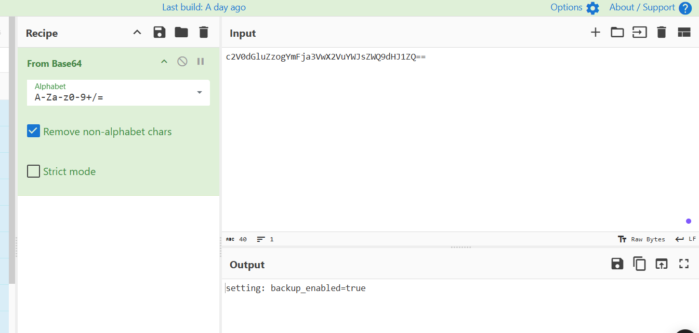

String 2: Not Legitimate (Malicious)
Encoded: ZGJfcGFzczogUEBzc3cwcmRfQ2xvdWRfMjAyNiE=
Decoded: db_pass: P@ssw0rd_Cloud_2026!
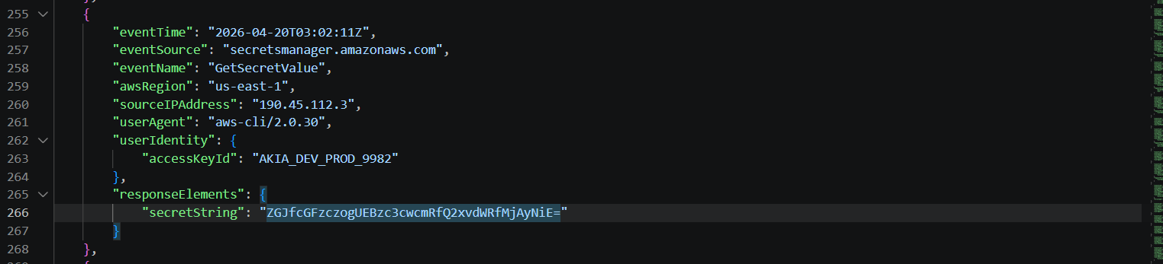
The attacker used the stolen key from their IP (190.45.112.3) to retrieve a secret from AWS Secrets Manager.The decoded value reveals a live database password: P@ssw0rd_Cloud_2026!
This credential gives the attacker access to the organisation's database — entirely separate from AWS.
This is a critical secondary breach: the attacker now has both cloud access AND database credentials

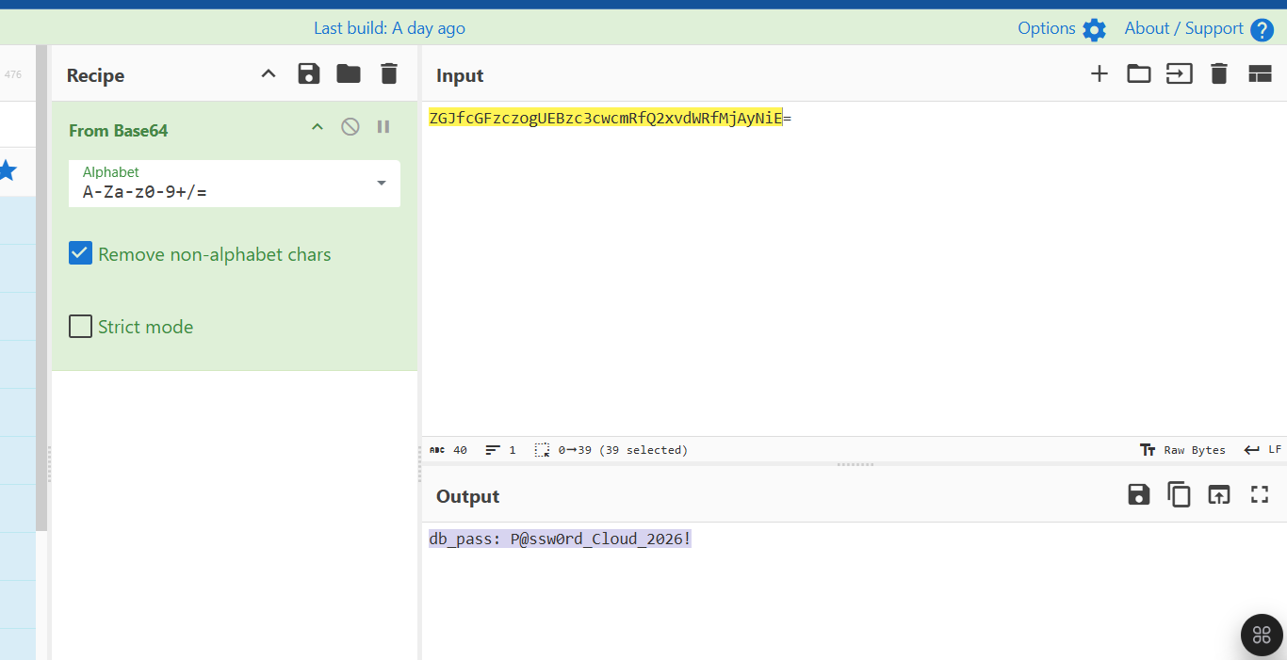

Comparison of both string

Attibutes | String 1 | String 2
Encoded Value | c2V0dGluZzogYmFja3VwX2VuYWJsZWQ9dHJ1ZQ== | ZGJfcGFzczogUEBzc3cwcmRfQ2xvdWRfMjAyNiE=
Decoded Value | setting: backup_enabled=true | db_pass: P@ssw0rd_Cloud_2026!
Source IP | 10.0.1.55 (internal DevOps) | 190.45.112.3 (external attacker)
Access Key | DevOps-Deployer/1.0 (tool-based) | AKIA_DEV_PROD_9982 (stolen)
Event Type | PutObject (writing config) | GetSecretValue (reading secret)

- Administrative Escalation
At 02:50:33Z, the attacker used the stolen key AKIA_DEV_PROD_9982 from IP 190.45.112.3 to call PutUserPolicy on the IAM user dev_user_musa named 'FullAdmin' to the user dev_user_musa with the following policy document:
"{\"Statement\": [{\"Effect\":\"Allow\",\"Action\":\"*\",\"Resource\":\"*\"}]}"

This policy translates to: allow ALL actions on ALL resources in the entire AWS account. By attaching this to dev_user_musa, the attacker elevated that user, who was already associated with the stolen key — to full administrator level, removing all permission boundaries and enabling every subsequent malicious action including secret extraction, S3 data access, backdoor user creation, and CloudTrail manipulation attempts.

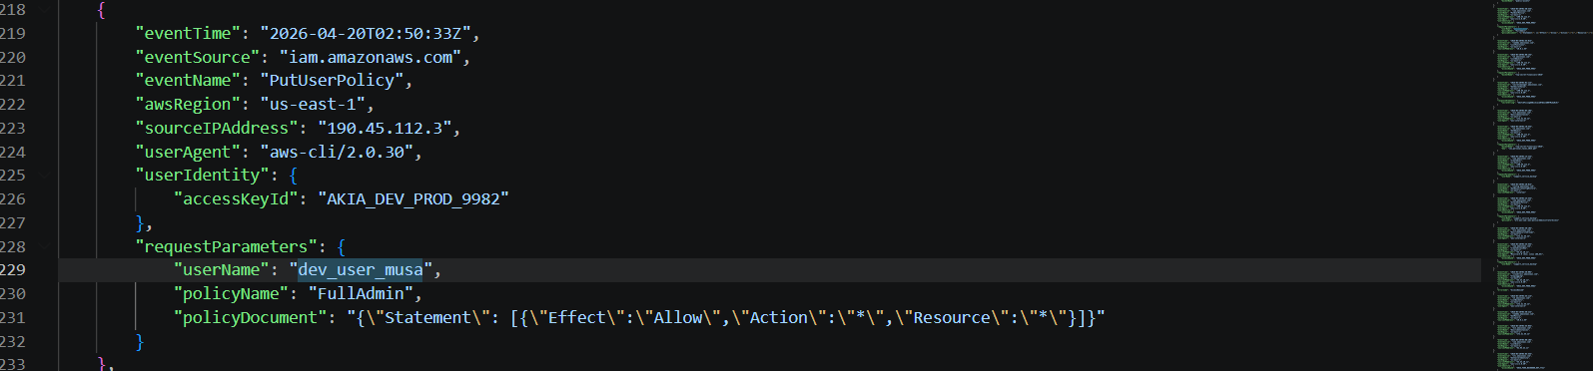

Before this action, the attacker could only perform actions that the stolen key's original permissions allowed. After this single API call, they had unrestricted access to the entire AWS environment — equivalent to being the root account user.

- The Theft
At 03:10:44Z, the attacker downloaded the file ceo_personal_taxes_2025.pdf from the S3 bucket top-secret-financials-2026 using the stolen access key from their primary attack IP. This represents confirmed data exfiltration.
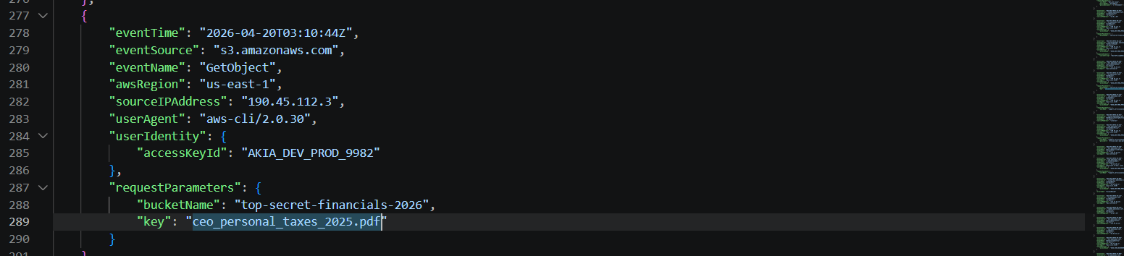

The attacker first performed ListObjects on the same bucket at 03:00:15Z about nine minutes before the download — to enumerate the bucket's contents and identify the most sensitive file before targeting it specifically.
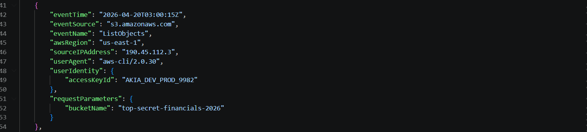

- Persistence and Evasion
Back door user created
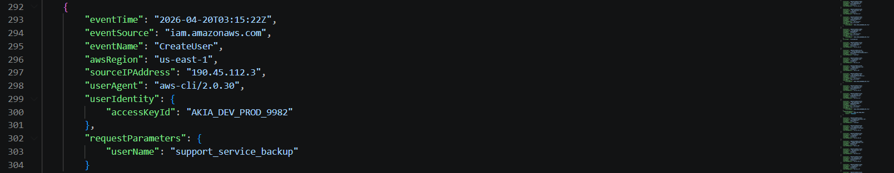

At 03:15:22Z the attacker created a new IAM user named support_service_backup — a name deliberately chosen to look like a legitimate AWS service account. At 03:25:33Z they attached the AWS-managed AdministratorAccess policy to this user, giving it full account control. At 03:35:45Z, switching to a second IP (45.33.10.11), they created an access key for this backdoor user, generating the key AKIA_FAKE_BACKDOOR_KEY_7721.

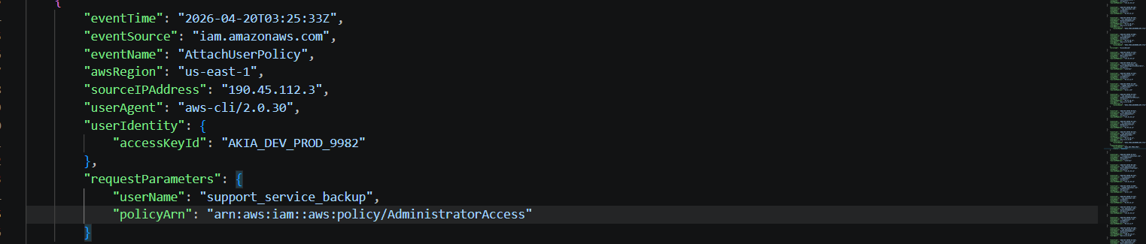

Final Action - Deactivation of Original Stolen Key

Final Action Against Original Stolen Key: UpdateAccessKey → status: Inactive
Timestamp: 2026-04-20T04:50:33Z

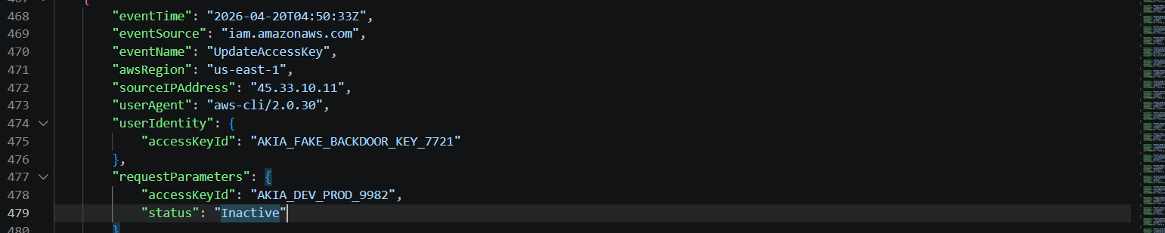

At 04:50:33Z, the attacker used their backdoor key (AKIA_FAKE_BACKDOOR_KEY_7721) to call UpdateAccessKey and set the original stolen key AKIA_DEV_PROD_9982 to Inactive status.
The attacker's final move was to deactivate the original stolen key AKIA_DEV_PROD_9982 using the backdoor key. The strategic reasoning is two fold:
- Remove the evidence trail: If defenders discover and revoke the original key, the attacker is still in (via the backdoor key). By deactivating it themselves first, they may delay the investigation — analysts may think the key was already revoked.
- Deny defenders re-use: Deactivating the key means the original user (and defenders) cannot use it to investigate or take remediation actions, buying the attacker more time.
- Maintain exclusive control: With the original key dead and the backdoor key active, only the attacker has privileged access — a full hostile takeover of the AWS environment

ATTACK CHAIN TIMELINE
Phase 1: Initaial Access and Reconnaissance

Timestamp | Source IP | Key used | Event | Meaning
01:15:33Z | 190.45.112.3 | AKIA_DEV_PROD_9982 | sts:GetCallerIdentity | Verifies stolen key is valid; identifies AWS account
01:25:44Z | 190.45.112.3 | AKIA_DEV_PROD_9982 | iam:GetAccountSummary | Maps account — number of users, groups, policies
01:40:00Z | 190.45.112.3 | AKIA_DEV_PROD_9982 | s3:ListBuckets | Lists all S3 buckets — looking for sensitive storage
02:05:45Z | 190.45.112.3 | AKIA_DEV_PROD_9982 | iam:ListUserPolicies | Targets dev_user_musa — checking their permissions
02:20:00Z | 190.45.112.3 | AKIA_DEV_PROD_9982 | iam:ListAttachedUserPolicies | Further profiling dev_user_musa for escalation target
02:30:10Z | 190.45.112.3 | AKIA_DEV_PROD_9982 | sts:GetSessionToken | Gets temporary credentials for next phase
02:40:00Z | 190.45.112.3 | AKIA_DEV_PROD_9982 | cloudtrail:DescribeTrails | Checks what logging is active before escalating

Phase 2 - Privilage Escalationand Credential Theft
Time stamp | Source IP | Event | Meaning
02:50:33Z | 190.45.112.3 | iam:PutUserPolicy — FullAdmin on dev_user_musa | FULL ADMIN GRANTED — Action:* Resource:* policy
03:00:15Z | 190.45.112.3 | s3:ListObjects — top-secret-financials-2026 | Locating sensitive files before exfiltration
03:02:11Z | 190.45.112.3 | secretsmanager:GetSecretValue | Database password stolen: P@ssw0rd_Cloud_2026!
03:10:44Z | 190.45.112.3 | s3:GetObject — ceo_personal_taxes_2025.pdf | DATA EXFILTRATION — CEO personal tax file downloaded

Phase 3 - Backdoor creation and persistence
Time stamp | Source IP | Event | Meaning
03:15:22Z | 190.45.112.3 | iam:CreateUser — support_service_backup | Backdoor user created disguised as service account
03:25:33Z | 190.45.112.3 | iam:AttachUserPolicy — AdministratorAccess | Backdoor user given full AWS administrator access
03:35:45Z | 45.33.10.11 (NEW IP) | iam:CreateAccessKey — support_service_backup | Backdoor key AKIA_FAKE_BACKDOOR_KEY_7721 created
03:40:00Z | 45.33.10.11 | cloudtrail:StopLogging — AccessDenied | Attempted to disable audit trail — BLOCKED

Phase 4 - Cover Track
Time stamp | Source IP | Event | Menaing
04:05:44Z | 45.33.10.11 | AKIA_FAKE_BACKDOOR_KEY_7721 | sts:GetCallerIdentity
04:10:00Z | 45.33.10.11 | AKIA_FAKE_BACKDOOR_KEY_7721 | s3:DeleteBucket — AccessDenied
04:35:44Z | 45.33.10.11 | AKIA_FAKE_BACKDOOR_KEY_7721 | iam:GetAccountPasswordPolicy
04:50:33Z | 45.33.10.11 | AKIA_FAKE_BACKDOOR_KEY_7721 | iam:UpdateAccessKey — AKIA_DEV_PROD_9982 set Inactive

Indicator of Compromise (IOCs)
Type | Value | Context
Attacker IP 1 | 190.45.112.3 | Primary attack IP — all initial reconnaissance and escalation
Attacker IP 2 | 45.33.10.11 | Persistence IP — backdoor creation and key deactivation
Stolen Access Key | AKIA_DEV_PROD_9982 | Compromised developer/production key used for bulk of attack
Backdoor Access Key | AKIA_FAKE_BACKDOOR_KEY_7721 | Attacker-created persistence credential
Backdoor IAM User | support_service_backup | Malicious IAM user with AdministratorAccess
Stolen Secret | db_pass: P@ssw0rd_Cloud_2026! | Database password extracted from Secrets Manager
Exfiltrated File | ceo_personal_taxes_2025.pdf | CEO personal tax document stolen from top-secret-financials-2026
Malicious Policy | FullAdmin — Action:* Resource:* | Inline policy applied to dev_user_musa for full escalation

RECOMMENDATION
Containment
- Deactivate and revoke AKIA_DEV_PROD_9982 and AKIA_FAKE_BACKDOOR_KEY_7721 immediately.
- Disable and delete IAM user support_service_backup and all its associated keys and policies.
- Remove the FullAdmin inline policy from dev_user_musa.
- Rotate the database password db_pass: P@ssw0rd_Cloud_2026! across all systems using it.
- Audit who has accessed the top-secret-financials-2026 bucket and notify affected parties of the CEO personal tax document breach.
Investigation
- Notify the CEO that their personal tax document (ceo_personal_taxes_2025.pdf) has been exfiltrated — this may require legal and regulatory notification.
- Determine how the key AKIA_DEV_PROD_9982 was originally stolen — check developer machines, code repositories, and CI/CD pipelines for exposed credentials.
- Review S3 bucket top-secret-financials-2026 permissions — it should not be accessible via standard developer keys.
CONCLUSION
This investigation confirms a complete, multi-stage AWS account compromise. The threat actor demonstrated significant operational sophistication: they conducted deliberate reconnaissance before escalating, used obfuscated credentials to obscure critical stolen data in plain sight, pivoted IP addresses at key moments, created a convincingly named backdoor account, and attempted to erase their tracks by disabling audit logging and deactivating the original stolen key. The compromise resulted in the exfiltration of highly sensitive PII (the CEO's personal tax return) and a critical database credential.

